**DAILY ONLINE ACTIVITIES SUMMARY**

|  |  |  |  |  |  |  |  |  |
| --- | --- | --- | --- | --- | --- | --- | --- | --- |
| **Date:** | **03-06-2020** | | | | | **Name:** | **SHAIFA SHALA** | |
| **Sem & Sec** | **6 B** | | | | | **USN:** | **4AL17CS084** | |
| **Online Test Summary** | | | | | | | | |
| **Subject** | | **PYTHON APPLICATION PROGRAMMING** | | | | | | |
| **Max. Marks** | | **20** | | **Score** | | | **19** | |
| **Certification Course Summary** | | | | | | | | |
| **Course** | **LEARN BASICS OF DATA STRUCTURES AND ALGORITHMS IN C++** | | | | | | | |
| **Certificate Provider** | | | **Udemy** | | **Duration** | | | **2.5 hours** |
| **Coding Challenges** | | | | | | | | |
| **Problem Statement:1 java program and 2 python program** | | | | | | | | |
| **Status: Executed** | | | | | | | | |
| **Uploaded the report in Github** | | | | | **Yes** | | | |
| **If yes Repository name** | | | | | **https://github.com/shaifashala/DailyReport.git** | | | |
| **Uploaded the report in slack** | | | | | **Yes** | | | |

Online Test Details: (Attach the snapshot and briefly write the report for the same)

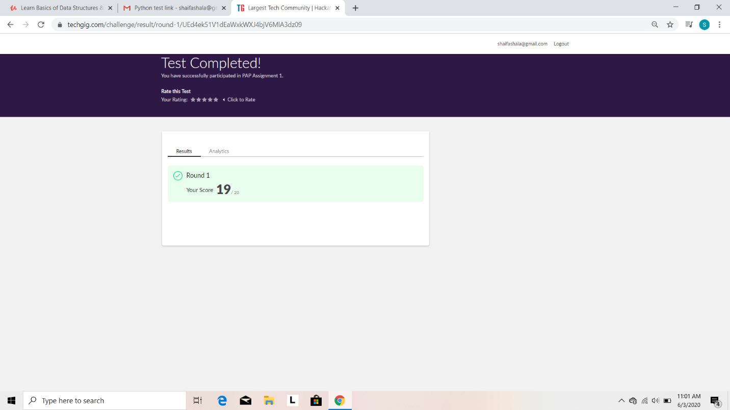

Certification Course Details: (Attach the snapshot and briefly write the report for the same)

Completed the course “Learn basics of data structures and algorithms in C++” and obtained a certificate.Posted both of then in github repository.

Certificate:

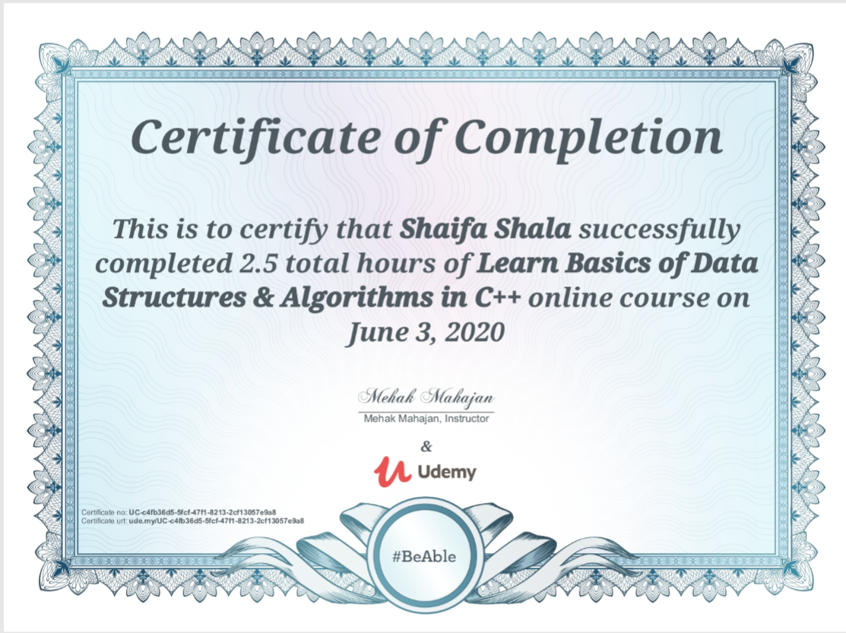

Coding Challenges Details: (Attach the snapshot and briefly write the report for the same)

Program1:

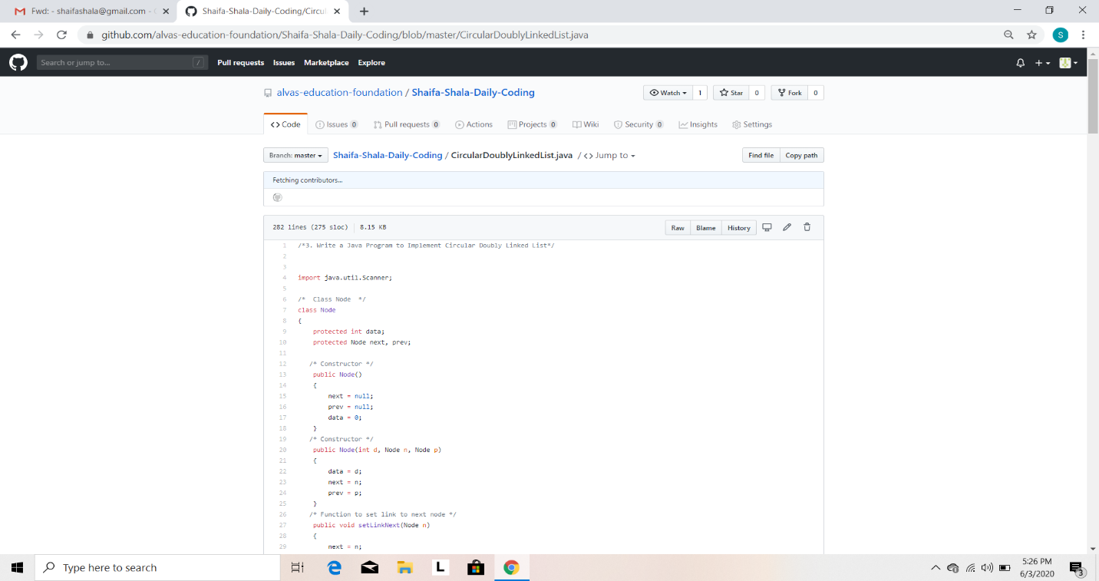

Program2:

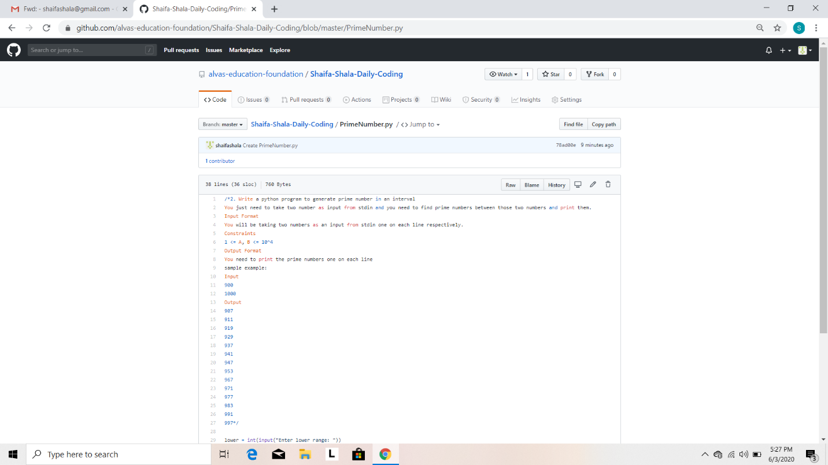

Program3:

